Platform4change submission form
Art & Mind

I wish to enter my own original piece of art work to Platform4change

Full Name: Click here to enter text.

Email address: Click here to enter text.

Phone numbers: Click here to enter text.

Medium: Click here to enter text.

Size of original artwork: Click here to enter text.

Name of piece Click here to enter text.
Statement (approx. 100 words): Click here to enter text.

I have photographed my work as a high quality jpeg/Tif file (minimum 300dpi) and emailed with this form to: Platform4change@outlook.com
OR print this form and send to Hull & East Yorkshire Mind, Wellington House, 108 Beverley Rd, Hull HU3 1XA
- I have enclosed a USB stick (clearly marked with my name/address/name of picture)

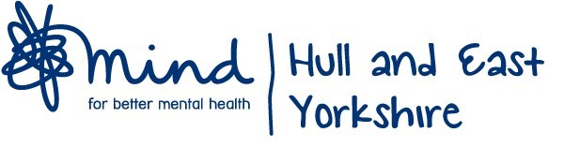
I agree to abide by the terms and conditions of the competition and if selected as one of the top 20 entries I will submit the original piece at my own cost and if selected as the overall winner, will attend the winner’s event on Thursday 8th September.

