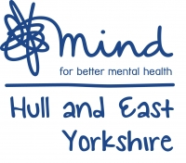
Want to help us raise money for Hull and East Yorkshire Mind?
Hull and East Yorkshire Mind
Wellington House, 108 Beverley Road
Hull / HU3 1YA

Hull and East Yorkshire Mind is a registered charity – No. 1101976

Tea and Talk Event
Join us for Tea and cake and raise awareness of mental health!

WHEN:

WHERE:


1 in 4 of us will experience mental health problems each year. Hull and East Yorkshire Mind believes no one should have to face this alone.
@MindHEY
Help us to raise money and #BreakTheStigma

