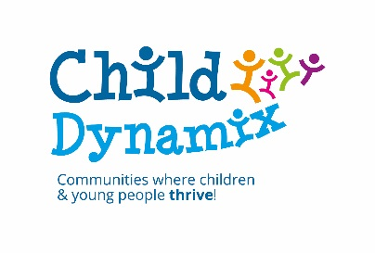

**Do you want to positively support and improve boys’ mental health?**



**‘Trainers of boys’ - Professional Development Training to improve Boys Mental Health**

**Free of Charge within Hull & East Riding**

This free course will enable you to look at the gender difference between boys and girls and is an opportunity to explore boys’ mental health.

**Aim**

**•** To raise awareness of different approaches to working with boys

**Objectives**

On completion of the course participants will:

• Acknowledge gender differences

• Explore mental health in boys

• Demonstrate appropriate skills to work with boys effectively

**This training will last one day, free of charge and a Buffet Lunch will be provided.**

**For dates and further info see Booking Form below**

**Queries: Jack Moore - Hull and East Yorkshire Mind, TEL 01482 240200**

Carers’ Information & Support Service

**‘Trainers of Boys’ Training Booking Form**

* Block bookings **are** welcome.
* We **do not** accept multiple bookings **on the same form**, any additional requests must be on separate forms.
* Please complete sections **1 and** **2 in full.**

|  |  |
| --- | --- |
| **Section 1: Your Details** | |
| **NAME & JOB TITLE:** |  |
| **ORGANISATION** |  |
| **ORGANISATION TYPE:**  Local Authority  Health  Education  Young People Services  Family Services  Other (Please specify) _____________________________ | |
| **ORGANISATION ADDRESS** |  |
| **WORK TEL NUMBER** |  |
| **E-MAIL:** |  |
| **PLEASE INFORM US OF SPECIAL REQUIREMENTS:** |  |
| **LINE MANAGER NAME IN FULL:** |  |

|  |  |  |  |
| --- | --- | --- | --- |
| **Section 2: Please select One Date below indicating selection with an “X”** | | | |
| **Wednesday 11th January 2017** | **9:30am – 4.30pm** | **The Courtyard, Boothferry Road, Goole, DN14 6AE** |  |
| **Thursday 19th January 2017** | **9:30am – 4.30pm** | **Centre 88,** Saner Street Hull HU3 2TR |  |
| **Friday 3rd February 2017** | **9:30am – 4.30pm** | **St Nicholas Community Centre** - 148 Holme Church Lane, Beverley HU17 0PY |  |
| **Monday 20th February 2017** | **9:30am – 4.30pm** | **The Hut**, 187E Preston Road, Hull, HU9 5UY |  |
| **Thursday 2nd March 2017** | **9:30am – 4.30pm** | **Cherry Tree Centre**, 117 Cherry Tree Lane, Beverley, HU17 0AY |  |
| **Thursday 9th March 2017** | **9:30am – 4.30pm** | **Centre 88,** Saner Street Hull HU3 2TR |  |

*Training is on a first come first served basis. *Training marked in red is now full up

By submitting this form to email address below you are agreeing for ‘Trainers of Boys’ , part of Hull and East Yorkshire Mind & Child Dynamix to hold your details on our training database where your information is stored and protected under the terms of The Data Protection Act 1998.

**Return to Jack Moore at** [**jmoore@HEYMind.org.uk**](mailto:jmoore@HEYMind.org.uk)

**Following successful booking you will receive confirmation via email with further details on training.**